Ques 1 – Prefect

Ques 2 – 3.4.11 version

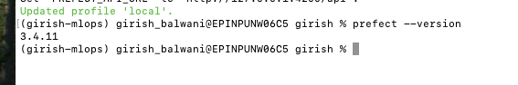

Ques 3 – Total records – 3,403,766 rows

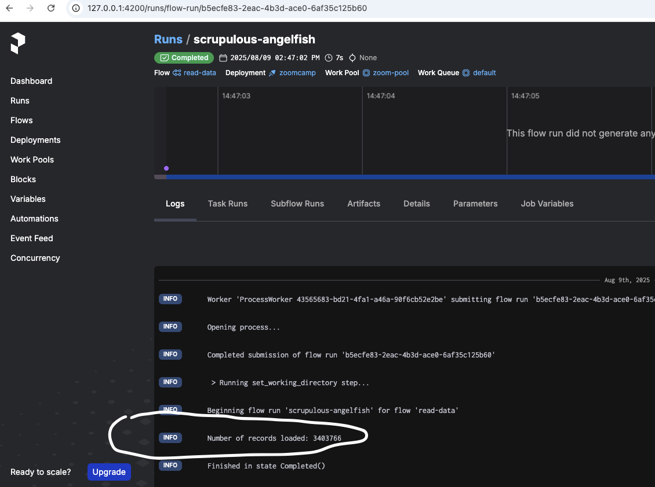

Ques 4 – 3,316,216 after filtering

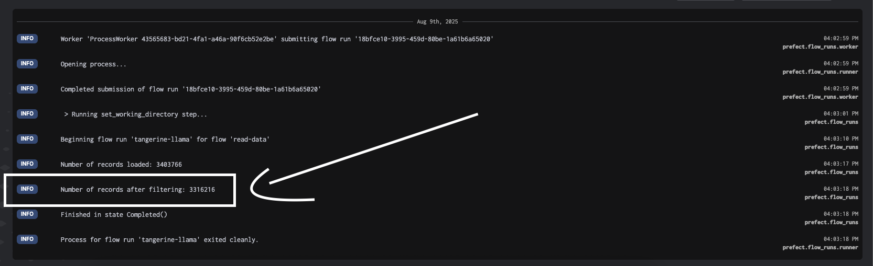

Ques 5 – 24.77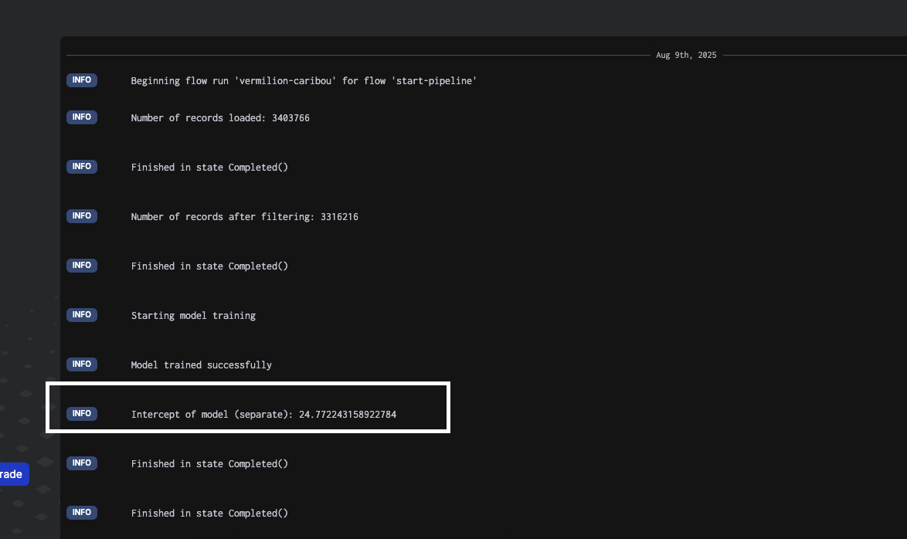

Ques 6 – size is 4501 model_size_bytes

Attaching prefect pipeline, mlflow experiment screen shots

